Part 2

Question 2:

- Retrieve total commission for each city (1pt)

SELECT a.cust_name AS "city",

a.city, b.commission

FROM customer a

INNER JOIN salesman b

ON a.salesman_id=b.salesman_id

WHERE b.commission>.10;

- Retrieve all customer whose salesman has total commission is larger than 0,12, sorted by commission.

SELECT a.cust_name AS "Customer Name",

a.city, b.name AS "Salesman", b.commission

FROM customer a

INNER JOIN salesman b

ON a.salesman_id=b.salesman_id

WHERE b.commission>.12;

Part1

import pytest

a = [2,5,7,8]

def nguyento(A):

T = True

F = False

prime = True

C = 0

B = len(A)

for i in range(B):

if (A[i] == 2 ):

C = C + 1

elif (A[i] < 2):

prime = False

elif (A[i] % 2 == 0):

prime = False

else :

for n in range(2,A[i]):

if (A[i] % n == 0 ):

prime = False

else :

C = C + 1

if (C >= 2):

return T

if (C < 2 ):

return F

print(nguyento(a))

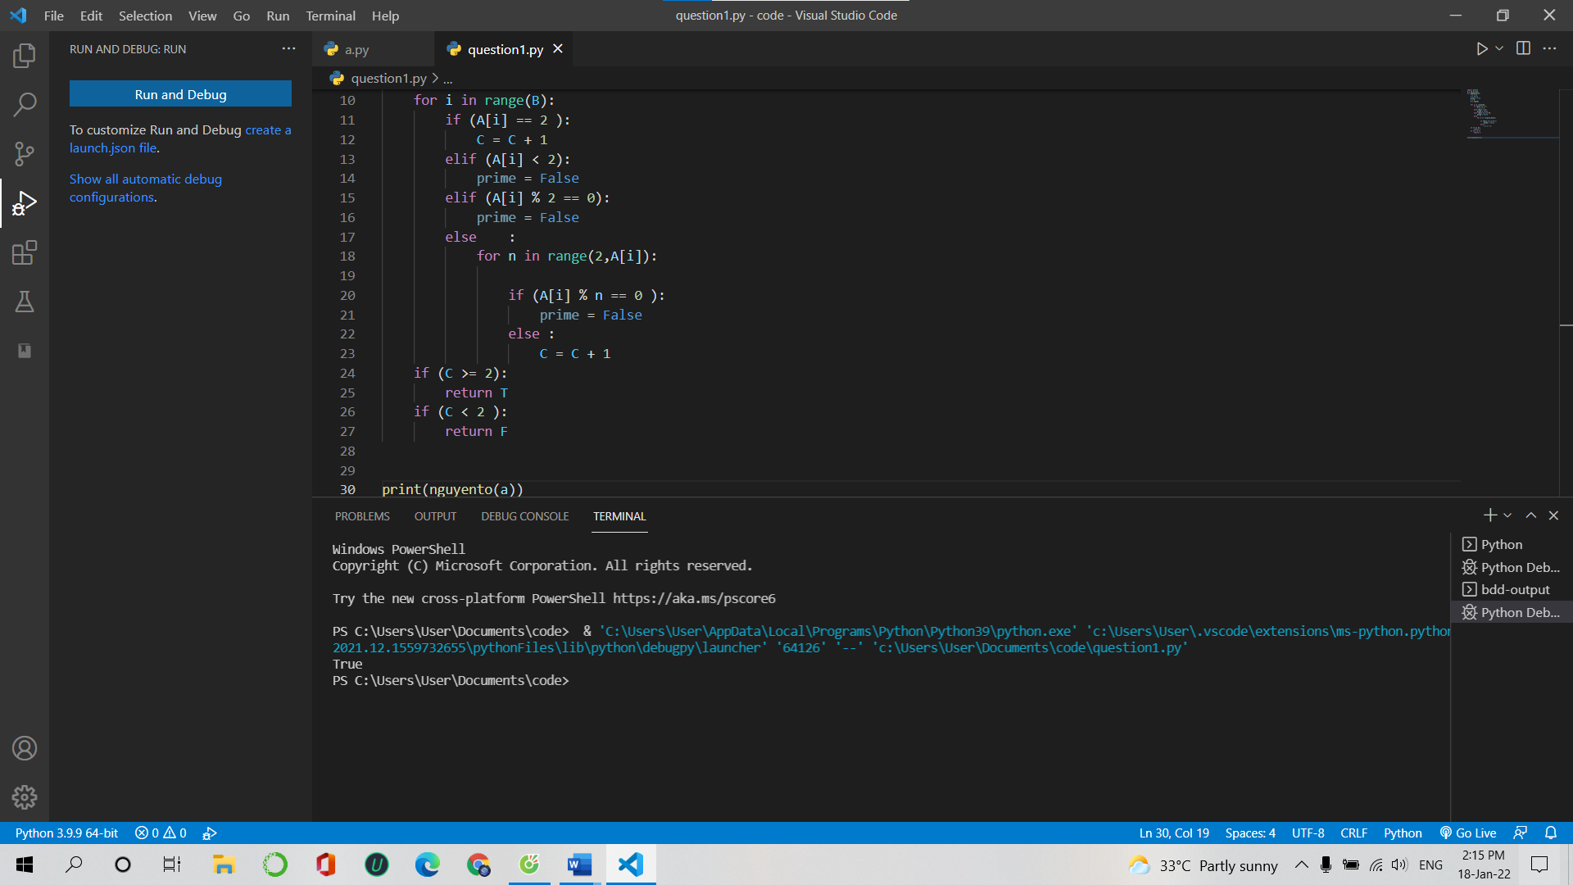

1. PYTEST

